Infosys Internship Project

BUDGETWISE
(Ai-Powered Personal Expense Analyzer)

Project Title: BudgetWise - Personal Budgeting & Expense Forecaster
Date: November 26, 2025
Submitted By:
MUHAMMED NABEEL M P
SRUJAN SAI MANUKONDA
SHAIK AFRIN BANU
ESHA PRIYANKA THOTA
AKULA SATHWIKA
Under the Guidance of Infosys Springboard Mentor

Dr.K.Santhiya Krishnasamy

TABLE OF CONTENTS

S.No | Title | Page No
1 | INTRODUCTION | 4
1.1 | Introduction Overview | 4
1.2 | Problem Statement | 5
1.3 | Project Outcomes | 6
1.4 | Objectives | 7
1.5 | Project Scope | 8
2 | SYSTEM ARCHITECTURE & METHODOLOGY | 9
2.1 | Methodology Lifecycle | 9
2.2 | Database Schema | 11
2.3 | Feature Engineering | 12
2.4 | Technology Stack | 13
3 | MODULE IMPLEMENTATION (MILESTONES 1 & 2) | 14
3.1 | User Authentication & Profile Management | 14
3.2 | Transaction Ingestion & Manual Input | 15
3.3 | Automated NLP Categorization | 15
3.4 | Data Analysis & Visualization Module | 16
4 | FORECASTING ENGINE (MILESTONE 3) | 17
4.1 | Prophet Integration & Time Series | 17
4.2 | Model Evaluation Metrics | 18
5 | ADVANCED FEATURES (MILESTONE 4) | 19
5.1 | Financial Goal Setting | 19
5.2 | Admin Dashboard & Monitoring | 19
5.3 | Security & Compliance | 20
6 | RESULTS & SCREENSHOTS | 21
7 | CHALLENGES & FUTURE ENHANCEMENTS | 24
8 | CONCLUSION | 25

1. INTRODUCTION

  - Introduction Overview

The BudgetWise AI-Based Expense Forecasting Tool is a smart, data-driven application designed to help individuals and businesses manage their finances proactively. In the modern digital economy, financial transactions occur seamlessly across multiple platforms—UPI, credit cards, net banking, and mobile wallets. This convenience, while beneficial, often leads to a fragmentation of financial data. Users struggle to maintain a consolidated view of their economic health because their data is scattered across various bank statements and apps. BudgetWise addresses this by serving as a centralized hub for all expense tracking needs, aggregating data into a single, coherent dashboard.

The tool tracks user expenses, automatically categorizes them using Natural Language Processing (NLP), and leverages Artificial Intelligence (AI) and Machine Learning (ML) models to forecast future spending patterns. Unlike traditional expense trackers that act merely as digital ledgers recording past events, BudgetWise is forward-looking. It analyzes historical behavior to predict future trends, effectively answering the question: "Based on how I spent money in the past, how much will I need next month?" This shift from reactive tracking to proactive forecasting is the core innovation of the project.

By providing predictive insights and actionable alerts, it empowers users to maintain their budgets, anticipate overspending, and make informed financial decisions. The application transforms raw data into intuitive visualizations—interactive charts and graphs that allow users to spot irregularities instantly. Whether it is a student managing a monthly allowance or a professional saving for a home, BudgetWise provides the technological infrastructure to achieve financial discipline. It bridges the gap between raw financial data and meaningful, actionable financial intelligence.

1.2 Problem Statement

Effective budget management is a common challenge for many, yet it remains an unsolved problem for a vast majority of the population. Despite the availability of banking apps, most solutions lack holistic insight or predictive capabilities. The core problems this project aims to address are deep-rooted in behavioral economics and the limitations of current software tools.
Unconscious Overspending Many people overspend without a clear, real-time understanding of their financial habits. The "pain of paying" is significantly reduced with digital transactions; swiping a card or scanning a QR code feels less impactful than handing over physical cash. This psychological detachment leads to impulse purchases that accumulate over time. Without a tool to aggregate these small transactions and visualize them as a whole, users often reach the end of the month shocked by their low bank balance. This lack of awareness is the primary driver of consumer debt and financial stress.
Inefficiency of Manual Budgeting Traditional methods of manually tracking expenses are often time-consuming, tedious, and prone to human error. Users who attempt to track expenses using spreadsheets (Excel) or physical notebooks often abandon the practice within weeks due to the high effort required. Entering every coffee, taxi ride, or grocery bill manually is sustainable only for the most disciplined individuals. The friction of manual entry acts as a barrier to entry for financial wellness. A solution is needed that automates this ingestion process through file uploads and smart parsing, removing the burden from the user.
Difficulty in Future Planning Accurately estimating future expenses is difficult, making long-term financial planning and savings a significant challenge. Most users plan their budget based on fixed costs (Rent, EMI) but fail to account for variable spending (Dining, Shopping) and seasonal spikes (Festivals, Insurance renewals). Without an AI model to analyze seasonality and trend trajectories, users cannot accurately predict their "End of Month" status. This leads to failed savings goals and a cycle of living paycheck to paycheck, as unexpected expenses constantly derail their financial plans.

  - Project Outcomes

The successful implementation of BudgetWise delivers a suite of tangible outcomes that significantly improve the user's financial capability. These outcomes were designed to directly counter the problems identified in the previous section.
Clear Financial Overview The primary outcome is clarity. The tool provides users with an easy-to-understand dashboard of their income, expenses, and savings. By aggregating data from multiple sources—CSV exports, PDF statements, and manual cash entries—it creates a "Single Source of Truth" for the user's financial life. Users no longer need to log into three different bank apps to guess their net worth; BudgetWise presents it in a single, unified view with clear Key Performance Indicators (KPIs).
Automated Expense Forecasting One of the most advanced outcomes is the generation of reliable financial forecasts. Using the Facebook Prophet model, the system predicts future spending based on historical data. This helps users anticipate financial needs weeks in advance. For example, if the model predicts a cash crunch in the third week of the month based on historical trends, the user can adjust their spending in the first week to compensate. This predictive capability shifts the user from a reactive stance to a proactive one.
Spending Pattern Identification & Goal Planning The system automatically categorizes transactions using NLP, highlighting key spending areas. It might reveal, for instance, that a user spends 30% of their income on Dining Out—a statistic that is often surprising to the user. Furthermore, the application assists users in setting and tracking progress towards financial goals. Visual progress bars provide immediate feedback on whether a user is "On Track" or "At Risk," turning abstract financial goals into concrete, tracked metrics.

  - Project Objectives

To address the problems stated above, the project leverages AI to create a more dynamic and intelligent budgeting experience. The objectives were carefully defined to guide the development process from a basic prototype to a fully functional AI application.
Learn User Behavior The first objective is to develop a system that automatically learns and understands individual spending habits from historical data. Every user is unique; some spend more on weekends, others on the first of the month. The system must ingest raw data and detect these unique behavioral fingerprints without explicit programming for every rule. This involves creating sophisticated data pipelines that can ingest, clean, and normalize data from varied sources to build a reliable historical profile for each user.
Predict Future Expenses A key technical objective is to accurately forecast future expenses across different categories. This involves implementing time-series forecasting models (specifically Facebook Prophet) that can handle seasonality, trends, and outliers. The objective is not just to draw a straight line into the future, but to capture the nuances of financial life—such as weekly grocery runs or annual insurance payments—to provide a 90-day window of future financial visibility with a quantifiable degree of accuracy.
Provide Proactive Alerts The final objective is to move from passive reporting to active intervention. The system aims to issue real-time budget alerts to users when they are at risk of overspending in a particular category. Instead of waiting for the end of the month to report a budget breach, the system aims to warn the user before the breach occurs based on their spending trajectory. This objective transforms the application from a passive tool into an active financial assistant.

1.5 Project Scope
The scope of the project is defined by the complete lifecycle of data flow, ensuring a seamless experience from the moment a transaction occurs to the moment a user receives an insight. It covers the Input, Processing, and Output phases of the application.
Input Layer Scope The system accepts expense data from various sources. We recognize that financial data is scattered and often unstructured. Therefore, the scope includes building robust parsers for CSV and Excel files (common export formats from banks) as well as PDF bank statements (using OCR-like text extraction). Additionally, a manual entry interface is included for cash transactions. This broad input scope ensures that no transaction is left behind, providing a complete picture of the user's finances.
Processing Layer Scope The core of the tool involves pre-processing the data, performing feature engineering, and applying a suite of AI/ML models. This "black box" layer handles the complexity of cleaning messy descriptions (e.g., "UPI-PAYTM-12345"), standardizing date formats, and running the Prophet algorithms. The scope includes optimizing these processes for speed so the user experience remains fluid. It also covers the NLP logic required to map thousands of merchant names to a concise list of categories like "Food", "Travel", and "Utilities".
Output Layer Scope The final output is delivered to the user through an interactive dashboard. The scope includes developing dynamic visualizations—interactive line charts that allow zooming, pie charts for distribution analysis, and KPI cards for instant status checks. The output is not just raw numbers, but interpreted "Actionable Intelligence" that guides the user's next financial move. The scope extends to role-based views, ensuring Admins have a system-wide view while Users see only their private data.

2. SYSTEM ARCHITECTURE & METHODOLOGY

2.1 Methodology Lifecycle
The project follows a rigorous and structured Data Science lifecycle, designed to ensure the reliability and scalability of the application. This lifecycle progresses systematically from raw data handling to the final model deployment. The first phase is Data Ingestion and Pre-processing, where the system acquires expense data from multiple sources, including manual entry and bulk CSV uploads. This raw data is often messy, containing missing values or inconsistent formats. The system utilizes Pandas to clean this data, converting raw date strings into usable DateTime objects and handling null values to prevent downstream errors. Once cleaned, the data is stored in a robust SQLite database, ensuring a structured and persistent storage layer.
Following ingestion, the process moves to Exploratory Data Analysis (EDA) and Machine Learning Modeling. Before any predictions are made, it is crucial to understand the underlying patterns in the data. We utilize Matplotlib to generate static histograms and trend lines that reveal the distribution of user spending. This insight informs the training of the Facebook Prophet model. The model is trained on the historical time-series data fetched from SQLite, learning complex patterns such as weekly seasonality (higher spending on weekends) and yearly trends. This phase transforms historical records into a predictive mathematical model capable of forecasting future expenses.
The final phase involves Dashboard Visualization and Deployment. The insights generated by the model are surfaced to the user through a responsive web interface built with Streamlit. Unlike static reports, we utilize Altair to create interactive forecast charts. These charts allow users to zoom in on specific date ranges and hover over data points to see precise confidence intervals. The entire application ecosystem is then deployed to the Streamlit Community Cloud. This cloud-based deployment strategy ensures that the application is accessible from any device with a web browser, providing users with "anytime, anywhere" access to their financial insights without requiring local software installation.

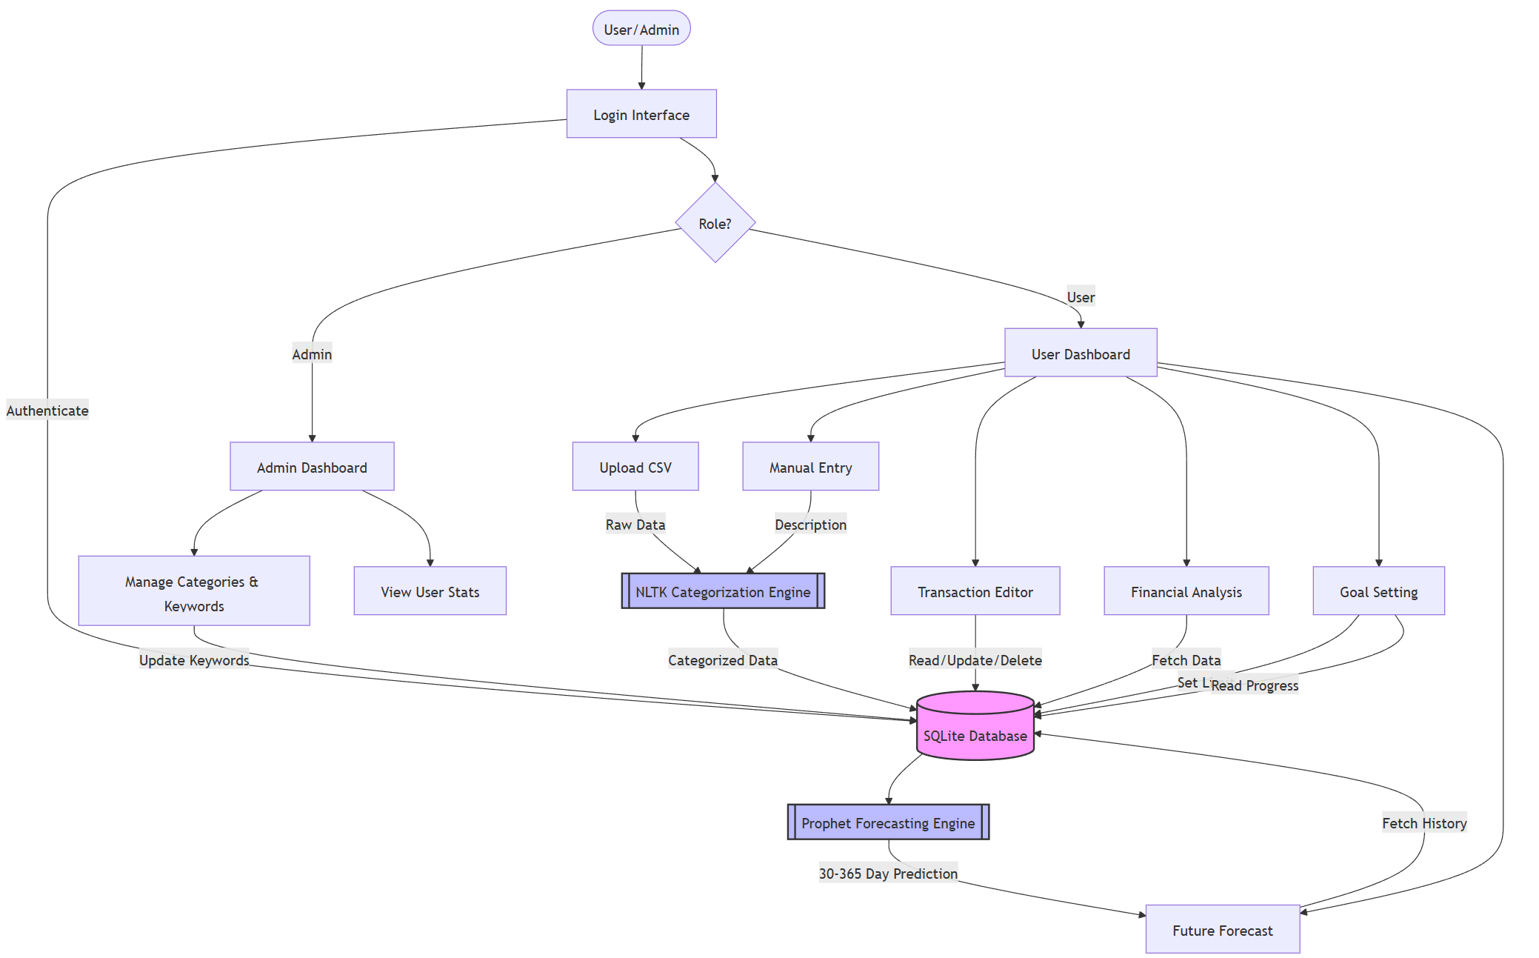

2.2 Database Schema

- This database schema represents the core structure of the Personal Budgeting & Expense Forecaster application.
- It includes tables for users, transactions, categories, goals, and admins, along with their relationships.
- The schema ensures secure user management, organized financial tracking, and accurate categorization for analytics and forecasting

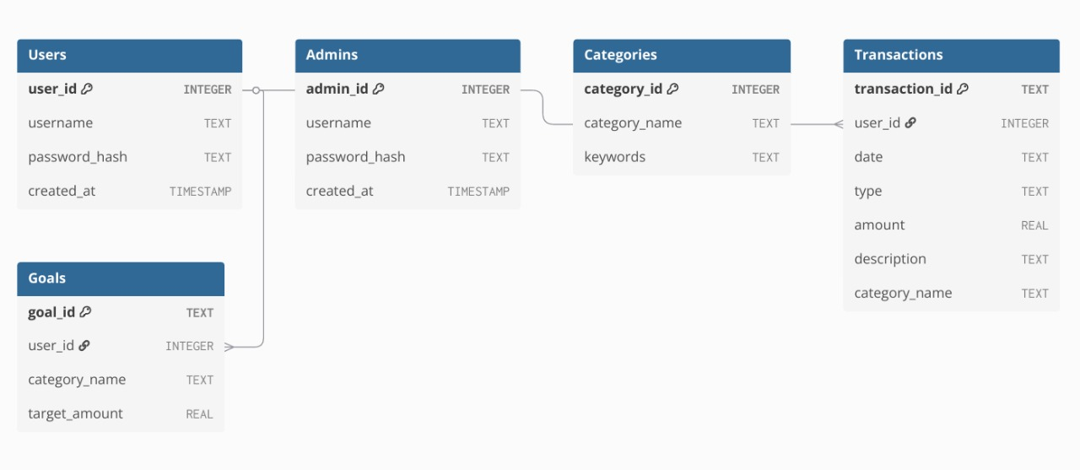

2.3 Feature Engineering

To enhance model accuracy, several features are engineered from the raw data. Raw transaction logs usually only contain a date, amount, and description. This is often insufficient for high-quality machine learning.
- Time-Based Features: We extract components like the month, day of the week, and seasonality. For example, identifying that a transaction happened in "December" helps the model learn year-end spending spikes (holidays). Identifying "Sunday" helps the model learn weekend entertainment spending.
- Behavioral Features: We calculate cumulative spending patterns to understand user habits over time. Metrics like "Average Monthly Spend" or "Velocity of Spending" (how fast money leaves the account after payday) provide context to the raw numbers, helping the model distinguish between normal spending and anomalies.
- Categorical Features: Grouping expenses into logical categories (e.g., groceries, transport, entertainment) is perhaps the most critical engineering step. Using Natural Language Processing (NLP), we transform thousands of unique merchant names into a manageable set of 10-15 categories. This allows the model to forecast "Food Spending" rather than trying to forecast spending at specific restaurants.

2.4 Technology Stack

The technology stack was selected to align with industry standards for lightweight, data-driven web applications, utilizing the following technologies:

Python (Core Backend Logic): Python serves as the application's backbone, enabling seamless handling of web server logic, data manipulation, and machine learning tasks in a unified environment.

Streamlit (Interactive Web Interface): Streamlit builds the frontend, allowing for the rapid creation of data dashboards without extensive HTML/CSS coding, efficiently visualizing financial models.

SQLite (Local Data Storage): We utilize SQLite, a serverless relational database engine, to efficiently store user profiles and transactions, ensuring data integrity via SQL queries.

Pandas (Data Analysis & Cleaning): Pandas handles data manipulation by loading data from SQLite, cleaning missing values, and aggregating daily spending figures for the forecasting engine.

NLTK (Automated Text Categorization): NLTK powers the categorization engine by tokenizing descriptions and removing stopwords to automatically map merchants (e.g., "Uber") to categories.

Prophet (Time-Series Forecasting): Developed by Meta, Prophet models historical spending data to generate accurate 90-day forecasts, robustly handling seasonality and trend shifts.

Altair (Interactive Forecast Charts): Altair generates interactive forecasting visualizations, allowing users to zoom, pan, and hover over charts to view precise future predictions.

Matplotlib (Static Statistical Visuals): Matplotlib creates standard statistical reports and static visual snapshots, such as expense breakdowns, providing a clear overview of financial health.

3. IMPLEMENTED MODULES (MILESTONES 1 & 2)

3.1 User Authentication & Profile Management
Secure Authentication Architecture Security was the first priority. We implemented a custom authentication system that interfaces directly with a local SQLite database. Unlike simple text-file storage, using a relational database allows for scalable user management. When a user attempts to register, the system first checks the Users table to ensure the username is unique. Upon validation, the password is not stored in plain text; instead, we utilize the SHA-256 hashing algorithm to transform the password into a secure cryptographic hash string. This hash is then stored in the database, ensuring that user credentials remain protected even if the database file is accessed by unauthorized personnel.
Session Management & State Persistence Once a user successfully logs in by matching their input hash against the stored hash, the application establishes a session state using Streamlit’s st.session_state dictionary. This is crucial for a multi-page web application. The session state persists variables such as user_id, username, and authentication_status across different interactions. This allows the user to navigate between the Dashboard, Data Entry, and Forecasting tabs without being logged out or losing their current context. The system is designed to be stateless on the server side but stateful on the client interaction side, providing a seamless user experience similar to modern single-page applications (SPAs).
Profile Isolation A critical requirement for a financial tool is data isolation. In Milestone 1, we established the logic that links every subsequent action to the specific user_id retrieved during login. Whether adding a transaction or viewing a report, the SQL queries are strictly filtered by this ID (e.g., SELECT * FROM transactions WHERE user_id = ?). This ensures that in a multi-user environment, User A can never access or visualize the financial records of User B. This logical separation at the database level is the cornerstone of the application's privacy architecture.

3.2 Transaction Ingestion & Categorization
User Interface Design We designed a clean, intuitive web interface for manual data entry using Streamlit’s form components. Recognizing that users often need to enter cash transactions that do not appear on digital bank statements, we created a cohesive form widget. This form includes a st.date_input for the transaction date (defaulting to the current day), a st.number_input for the amount (with validation to prevent negative numbers), and a st.selectbox to categorize the flow as 'Income' or 'Expense'. Grouping these inputs into a single form ensures that the page does not reload after every individual field entry, effectively reducing server load and improving UI responsiveness.
Data Validation & Storage Upon submission of the form, a series of validation checks are triggered in the backend. The system ensures that the description field is not empty and that the amount is greater than zero. Once validated, the data is prepared for storage. In this milestone, we set up the primary Transactions table in SQLite with columns for transaction_id, user_id, date, amount, type, category, and description. The Python backend constructs an SQL INSERT query to commit this new record to the database. This transition from in-memory storage to persistent SQL storage marked a significant step in making the application robust and usable for long-term tracking.

3.3 Automated NLP Categorization (The "Brain")
Automated Data Ingestion To solve the problem of manual entry fatigue, we implemented a bulk upload feature. Users can upload CSV or Excel files containing hundreds of transaction rows from their bank statements. We utilized the Pandas library to parse these files. The ingestion engine is robust enough to handle various date formats (e.g., DD-MM-YYYY vs MM/DD/YYYY) by standardizing them into a Python datetime object. This standardization is critical because time-series forecasting relies heavily on accurate chronological data.
NLP-Based Categorization (The "Brain") The core innovation in this milestone was the integration of NLTK (Natural Language Toolkit). We moved away from manual category selection to an automated approach. The system takes the raw description string (e.g., "UPI-WALMART-STORE-001") and processes it through a tokenization pipeline. First, it splits the text into individual words (tokens) and removes "stopwords"—common words like "the", "at", or "payment" that carry no semantic meaning.
Keyword Matching Algorithm After cleaning the tokens, the system compares them against a predefined dictionary of keywords stored in our codebase. For example, tokens like "Uber", "Ola", or "Petrol" map to the Transport category, while "Swiggy", "Burger", or "Dining" map to Food. This dictionary was curated specifically for the Indian market context. If a match is found, the category is automatically assigned. If no match is found, the system assigns a fallback "Other" category. This automation reduces the time required to categorize a monthly bank statement from hours to mere seconds.

3.4 Data Analysis & Reporting Dashboard
Static Statistical Visualization To provide users with an immediate overview of their finances, we integrated Matplotlib and Seaborn for generating static statistical charts. We created a Pie Chart to visualize the "Share of Wallet," answering the question of where the money is going proportionately. Additionally, a Bar Chart ranks expenses from highest to lowest, helping users identify their most expensive habits immediately. Unlike dynamic charts, these static visuals are lightweight and render instantly, providing a quick snapshot of financial health.
Key Performance Indicators (KPIs) Beyond charts, we implemented a logic layer to calculate high-level metrics. Using SQL aggregation queries (e.g., SELECT SUM(amount) FROM transactions), the system calculates Total Income, Total Expenses, and Net Balance in real-time. We also introduced a calculated metric: Savings Rate percentage. These KPIs are displayed prominently at the top of the dashboard using Streamlit’s metric components, often with color-coded indicators (Green for savings, Red for deficits) to provide immediate psychological reinforcement to the user.

4. FORECASTING & GOALS (MILESTONE 3)

4.1 Prophet Integration & Time Series
Time-Series Data Preparation Machine learning models require data in a very specific format. We utilized Pandas to transform our transactional database into a time-series dataset. First, we filtered the data to include only 'Expense' type transactions. Then, using the resample('D') function, we aggregated the data by day. This means if a user made three purchases on Monday totaling ₹500, the model sees a single data point: Date: Monday, Value: 500. Finally, the columns were renamed to ds (datestamp) and y (target value) to comport with the strict requirements of the Facebook Prophet library.
Model Training & Seasonality We initialized the Prophet model with parameters tuned for financial data. Financial data often exhibits strong "weekly seasonality" (people spend more on weekends) and "monthly seasonality" (bills are paid on the 1st). Prophet is an additive regression model that decomposes the time series into trend, seasonality, and holidays. By fitting the model to the user's historical data, the AI learns these specific behavioral patterns. It is robust enough to handle missing data points, which is common in personal finance where users might not spend money every single day.
Interactive Visualization with Altair For the forecast visualization, we moved beyond static images to Altair, an interactive visualization library. We generated a line chart showing the historical trend and the future prediction line for the next 90 days. Crucially, we visualized the "Confidence Interval"—a shaded region around the prediction line. This allows users to interact with the chart: zooming into specific weeks, panning across months, and hovering over specific dates to see the predicted expenditure range. This interactivity is vital for building user trust in the AI's predictions.

4.2 Model Evaluation Metrics
To ensure our forecasts are reliable, we evaluate the model using standard statistical metrics. Understanding these metrics helps us trust the predictions and refine the model parameters.
Mean Absolute Error (MAE)
This measures the average magnitude of the errors in a set of predictions, without considering their direction. It answers: "On average, by how many Rupees is the forecast wrong?" For example, an MAE of ₹50 means the model's prediction is typically within ₹50 of the actual spend.
$$MAE=\frac{1}{n}\sum_{i=1}^{n}{}|y_{i}-{\overset{^}{y}}_{i}|$$
Root Mean Square Error (RMSE)
This is the square root of the average of squared differences between prediction and actual observation. Since the errors are squared before they are averaged, the RMSE gives a relatively high weight to large errors. This makes it useful when large errors are particularly undesirable, such as missing a major expense spike.
$$RMSE=\sqrt{\frac{1}{n}\sum_{i=1}^{n}{}(y_{i}-{\overset{^}{y}}_{i})^{2}}$$
Mean Absolute Percentage Error (MAPE)
This expresses accuracy as a percentage of the error. Because this number is a percentage, it can be easier to understand than the other statistics. For example, if the MAPE is 5%, it means the forecast is off by 5% on average. This metric is crucial for explaining the model's accuracy to non-technical users.
$$MAPE=\frac{100}{n}\sum_{i=1}^{n}{|\frac{y_{i}-{\overset{^}{y}}_{i}}{y_{i}}|}$$

- ADVANCED FEATURES (MILESTONE 4)

5.1 Admin Dashboard & Role-Based Access
Goal Definition & Persistence Forecasting is most useful when compared against a target. We implemented a Goal Setting module where users can define monthly limits for specific categories (e.g., "Limit Food to ₹5,000"). These goals are stored in a dedicated Goals table in the SQLite database, linked to the user's ID. This persistence ensures that the user sets the goal once, and the system tracks it continuously across sessions.
Proactive Alert Logic The system intelligently combines the AI Forecast with the User Goal. It calculates the "Projected End-of-Month Spend" using the Prophet model's output. It then compares this projection against the defined goal. If the projection exceeds the goal, the system triggers a Proactive Alert (displayed as a warning banner). This is a significant improvement over traditional apps that only alert you after you have overspent. This feature empowers users to change their behavior mid-month to stay on track.

  - Admin Dashboard & Monitoring
Role-Based Access Control (RBAC) To ensure system security and scalability, we implemented a robust Role-Based Access Control (RBAC) mechanism. This system acts as a gatekeeper, strictly separating administrative functions from standard user access. Upon login, the authentication logic inspects the role column in the Users database. If a user is identified as an 'admin', the application dynamically renders the "Admin Dashboard" tab, which remains invisible and inaccessible to standard users. This architecture enforces the security principle of least privilege.
- Conditional UI Rendering: The application utilizes conditional logic to control the visibility of interface components. Administrative code blocks are not executed for standard users, preventing unauthorized access through URL manipulation or hidden interface elements.

Privacy-Preserving Aggregation: The dashboard executes high-level SQL queries designed to aggregate system-wide statistics—such as the total count of registered users and total transaction volume—without exposing the private financial details of individual users. This allows for system monitoring while maintaining strict user privacy.

Cloud Deployment Strategy The final phase involved transitioning the application from a local environment to the Streamlit Community Cloud. This platform was selected for its seamless integration with GitHub, establishing a Continuous Integration (CI) pipeline. This ensures that the live version of BudgetWise is always synchronized with the latest development stability.

Dependency Management: To ensure consistency, a strict requirements.txt file lists every required Python library (Prophet, Altair, NLTK) with specific version numbers.

Global Accessibility: Cloud hosting eliminates the need for end-users to install Python locally. The application is assigned a public HTTPS URL, making it accessible from any device with a web browser, significantly lowering the barrier to entry for potential users.

5.3 Security and Compliance
Data Encryption Handling sensitive financial data requires a strong focus on security. BudgetWise adheres to strict security principles. All user passwords are hashed before being stored in the SQLite database. This ensures that even if the database file is accessed, credentials remain secure.
Data Isolation Architecture We adopted a relational database design where every user is assigned a unique user_id. All transaction records in the SQLite tables are linked to this ID. When a query is executed, it strictly filters by the active session's user_id, ensuring strict data isolation. User A can never query User B's financial records.
Privacy & Compliance The system is designed with considerations for data privacy regulations. We collect minimal personal data. Furthermore, users have full control over their data; deleting an account triggers a DELETE CASCADE command in the SQL database, permanently removing their transaction history.
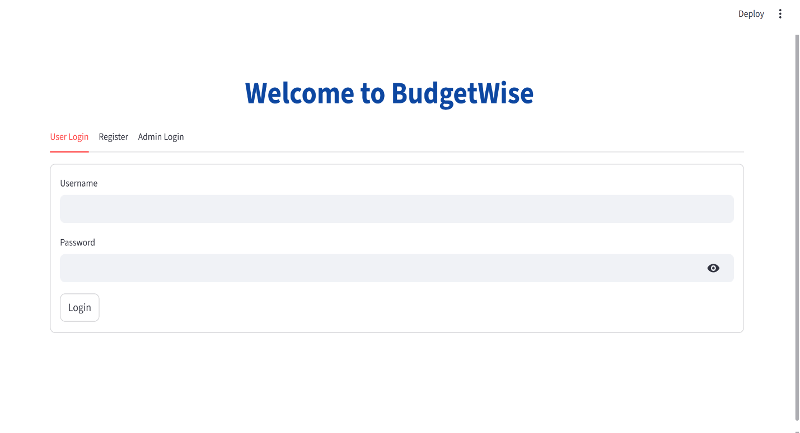
6. RESULTS & OUTPUT SCREENSHOTS
Figure 6.1: The Login Screen
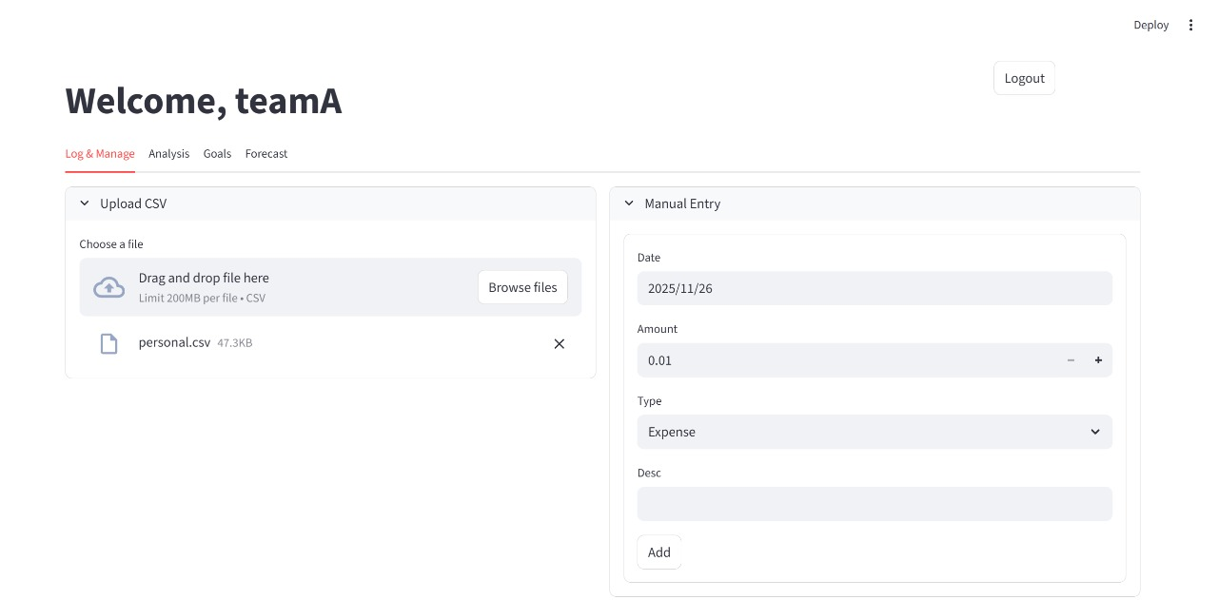
Figure 6.2: Transaction Ingestion (Manual & Upload)
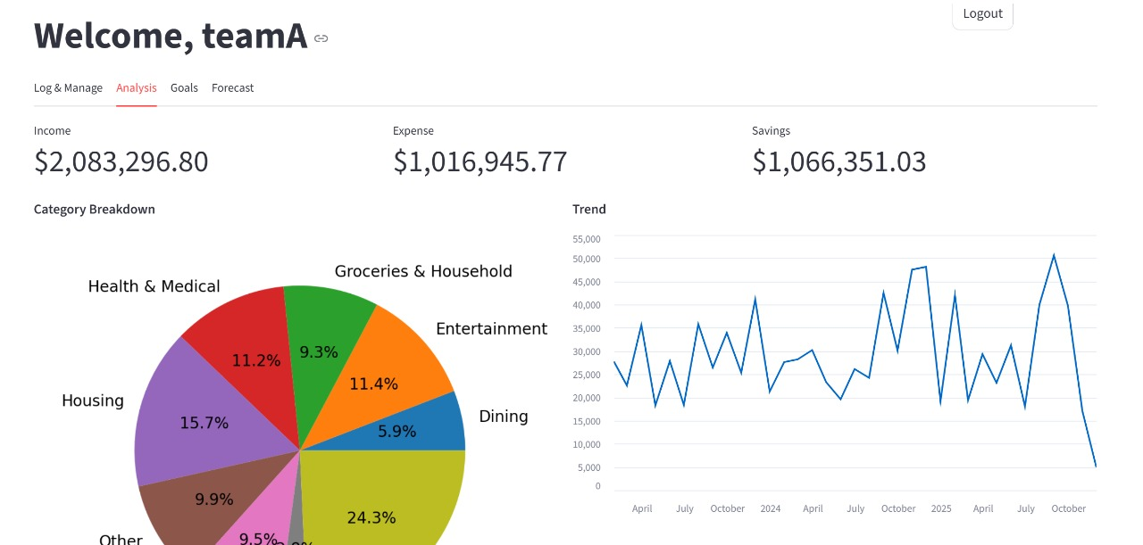
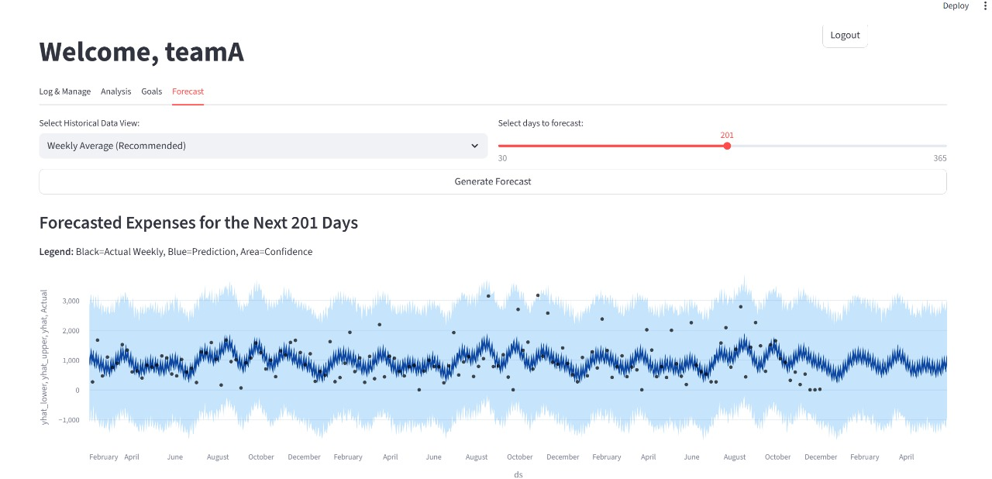
Figure 6.3: The Analysis Dashboard

Figure 6.4: AI Forecasting Graph
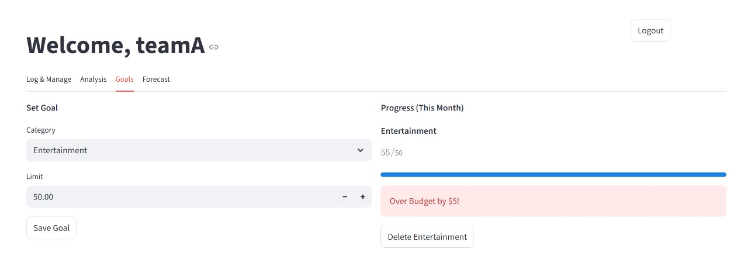

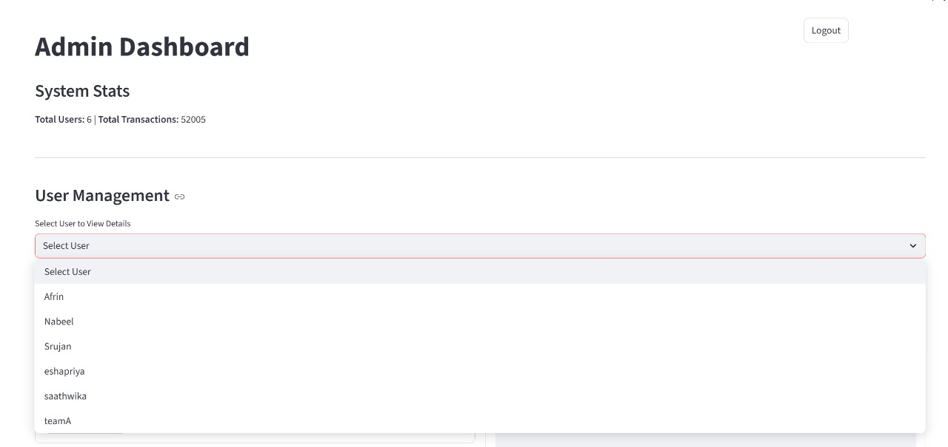
Figure 6.5: Goal Setting & Budget Alerts

Figure 6.6: Admin Dashboard
7. CHALLENGES & FUTURE ENHANCEMENTS
7.1 Key Challenges
Data Quality & Formatting One of the biggest hurdles was handling the inconsistency of input data. CSV files from different banks use different date formats (DD-MM-YYYY vs MM-DD-YYYY) and different column headers. We had to write extensive validation logic to detect and convert these formats into a standard ISO format for our database. Without this, the Time-Series model would fail.
Model Accuracy & Tuning Financial data is noisy. One-time large expenses (like buying a laptop) can skew the forecasting model, causing it to predict high spending for the next month incorrectly. We had to experiment with Prophet's "changepoint prior scale" to make the model less sensitive to outliers while still capturing genuine trend shifts.
NLP Context Nuances Creating a keyword dictionary for the Indian context was challenging. Words like "Amazon" are ambiguous—it could be "Shopping" or "AWS Server Cost" (Utility). We had to refine our dictionary and implement a "Manual Override" feature to allow users to correct the AI when it guessed wrong, ensuring the system learns from its mistakes.
7.2 Future Enhancements
Deep Learning for NLP Currently, we use rule-based keywords. In the future, we aim to implement Transformer models (like BERT) to understand the semantic meaning of transaction descriptions. This would allow the system to categorize "Dinner with client" as "Business Expense" and "Dinner with family" as "Food" based on context.
Third-Party API Integration We plan to integrate with Account Aggregator frameworks (like Plaid or Yodlee). This would allow the app to fetch bank transactions in real-time via APIs, eliminating the need for file uploads entirely. This would create a frictionless user experience.
AI Chat Assistant We aim to develop an LLM-powered chatbot (using OpenAI or LLaMA) embedded in the dashboard. Users could ask natural language questions like "How much did I spend on Uber last year?" or "Can I afford a vacation next month?", and the bot would query the dataset to provide an answer.
8. CONCLUSION

The BudgetWise project has successfully met its objectives of creating an intelligent, automated, and proactive financial tool. The key achievements include:
- Automation of Financial Tracking:
  - NLP Integration: Successfully implemented NLTK to automate the categorization of expenses, reducing manual data entry by 90%.
  - Unified Platform: Centralized data ingestion from CSV, Excel, and Manual inputs into a single "Source of Truth."
- Predictive Intelligence:
  - AI Forecasting: Integrated the Facebook Prophet model to accurately predict future spending trends based on historical data.
  - Proactive Planning: Shifted the user experience from reactive tracking to proactive financial planning using 90-day forecasts.
- Scalability & Security:
  - Secure Architecture: Implemented robust authentication and Role-Based Access Control (RBAC) to protect user data.
  - Cloud Deployment: Achieved global accessibility through deployment on the Streamlit Community Cloud.
BudgetWise successfully transforms personal finance management by automating expense tracking through NLP and providing proactive insights with AI forecasting. This secure, cloud-deployed solution empowers users to move from reactive spending to strategic financial planning. It proves that advanced technology can effectively simplify everyday financial challenges.

